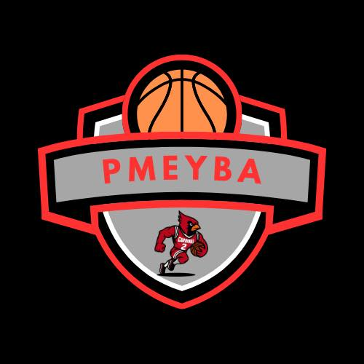
Pocono Mountain East Youth Basketball Association
Code of Conduct

1. Purpose & Scope
- Mission Statement: To foster a positive, inclusive, and safe basketball environment where youth athletes can develop skills, sportsmanship, and a lifelong love of the game.
- Scope: This Code applies to all persons involved in PMEYBA activities—players, coaches, parents, spectators, officials, and volunteers—during practices, games, tournaments, and any related event or communication (including online/social media).

2. General Principles
- Demonstrate respect always—for teammates, opponents, officials, coaches, and facilities.
- Promote fair play, inclusion, and fun.
- Prioritize safety—emotional, physical, and mental—for everyone involved.
- Encourage positive communication and constructive feedback, free of hostility or harassment.

3. Players
- Effort & Attitude: Give full effort, arrive on time, attend practices, and maintain a positive mindset.
- Respect: Show respect to teammates, opponents, coaches, and officials. Shake hands after games and avoid trash-talking.
- Integrity: Follow game rules and cooperate fully with officials. No arguing or mocking.
- Safety & Care: Wear appropriate gear, speak up about injuries, and avoid dangerous behavior.

4. Coaches
- Role Modeling: Exhibit sportsmanship and ethical behavior in all interactions.
- Encouragement & Development: Focus on skill development, teamwork, and effort over winning.
- Fair Play: Provide all players with meaningful participation. Avoid favoritism.
- Respect for Officials: Accept and model deference to officials’ decisions, even when disagreeing.
- Child Safety: Create a supportive environment—report injuries, avoid unsafe drills, uphold safeguarding standards.

5. Parents & Spectators
- Supportive Behavior: Cheer positively and refrain from coaching or criticizing during games.
- Respect for All: Respect players, coaches, other spectators, and officials. No yelling, insults, or taunting.
- Constructive Dialogue: Direct concerns to coaches or league leadership via respectful, scheduled conversations outside of games.
- Set an Example: Be a role model for children—demonstrate good sportsmanship and community spirit.

6. Officials & Volunteers
- Fairness & Competence: Apply rules consistently and professionally. Be punctual and prepared.
- Neutrality: Remain unbiased—no preferential treatment.
- Professionalism: Communicate respectfully and clearly, and address concerns calmly.
- Safety First: Stop play if safety is compromised. Report serious incidents or misconduct promptly.

7. Shared Responsibilities
- Zero Tolerance: Intolerant of physical abuse, harassment, racism, discriminatory behavior, or profanity.
- Conflict Resolution: Minor issues handled by the respective coach or team parent. Major issues escalated to league leadership in writing (e.g., board members), with impartial review.
- Consequences: Progressive disciplinary approach—verbal warnings, written warnings, suspensions, or bans depending on severity and frequency. Document each step.
- Acknowledgment: Everyone must sign (or otherwise acknowledge) this Code before participating in any PMEYBA activity.

8. Implementation & Review
- Communication: Distribute the Code to all parties at the start of each season—via in-person meetings, email, or league website.
- Training: Offer brief orientation or resources for coaches, parents, and officials on expectations and best practices.
- Review Cycle: Annually review the Code, incorporate feedback, and update as needed.

Acknowledgment & Signature
By signing below, I acknowledge that I have read, understood, and agree to abide by the PMEYBA Code of Conduct. I understand that failure to comply may result in disciplinary action, including suspension or removal from participation in league activities.
Player Name: _________________________________________
Player Signature: ____________________________ Date: ____________
Parent/Guardian Name: ___________________________________
Parent/Guardian Signature: ______________________________ Date: ____________
Coach/Official (if applicable): ________________________________
Coach/Official Signature: __________________________ Date: ____________

